1. Prolog program to sum the integers from 1 to n

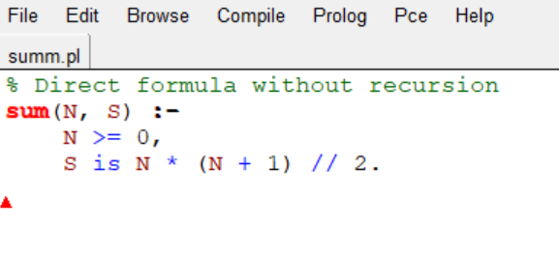

Output:

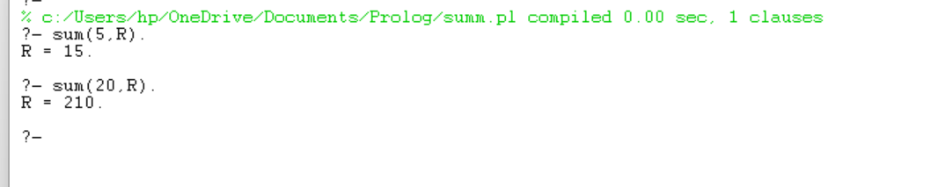

1. Prolog program for A DB with DOB

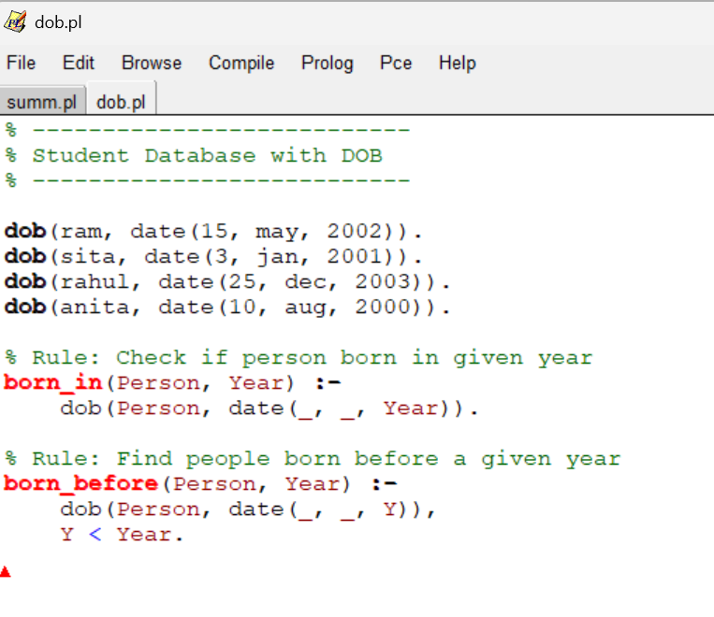

Output:

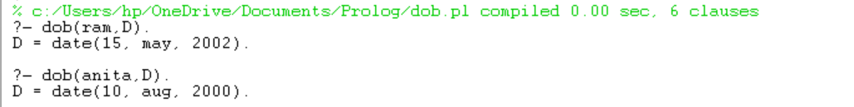

1. Prolog program for student subcode

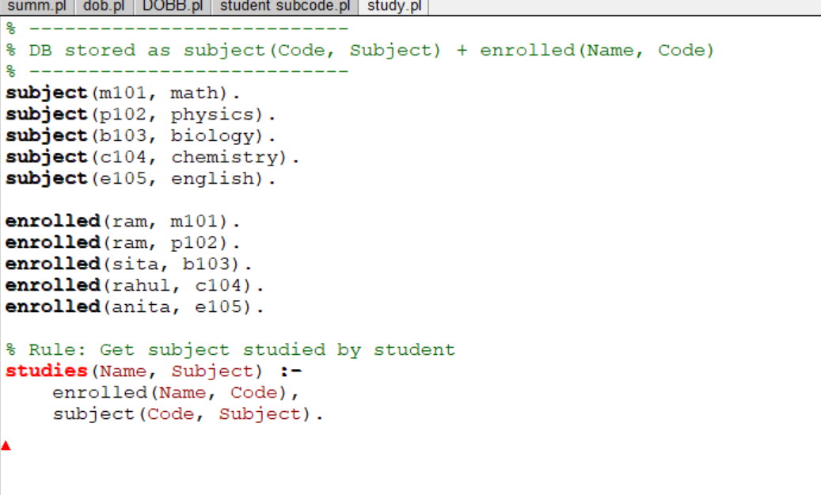

Output

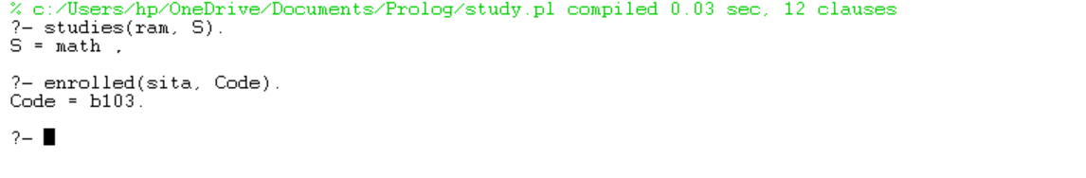

1. Prolog program for Planets DB

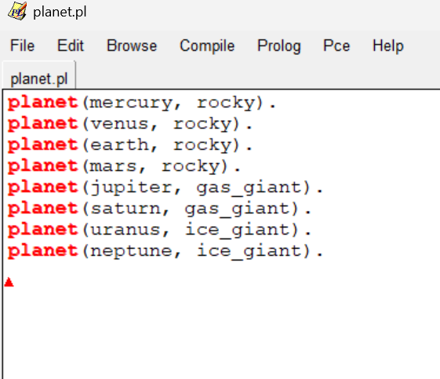

Output:

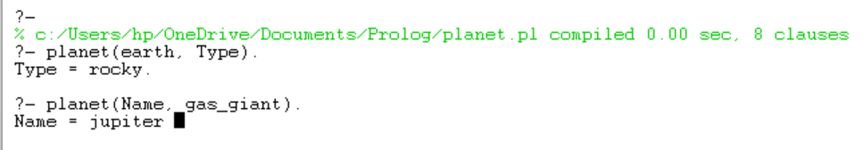

1. Prolog program for Tower of Hanoi

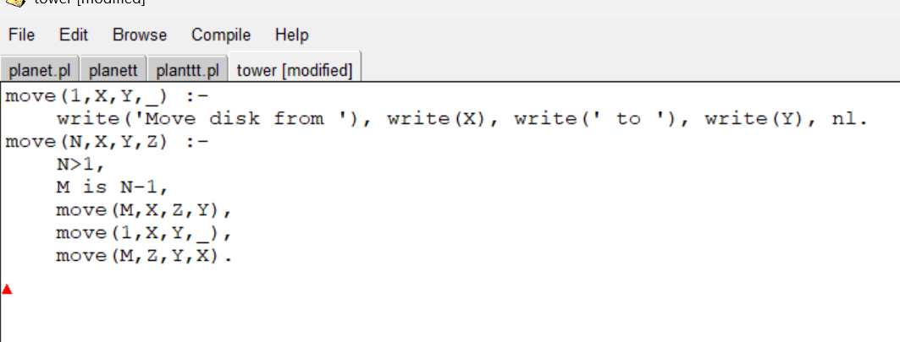

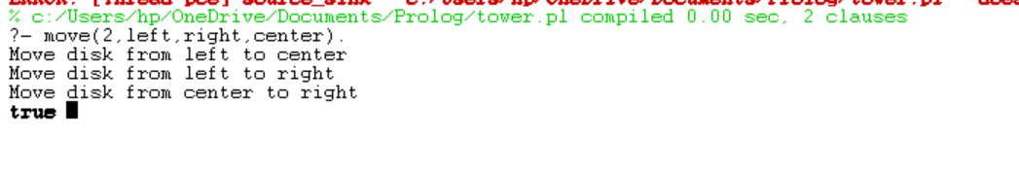

1. Prolag program to fin the particular bird can fly or not

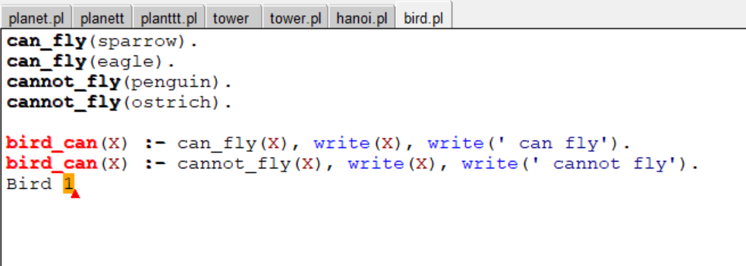

Output

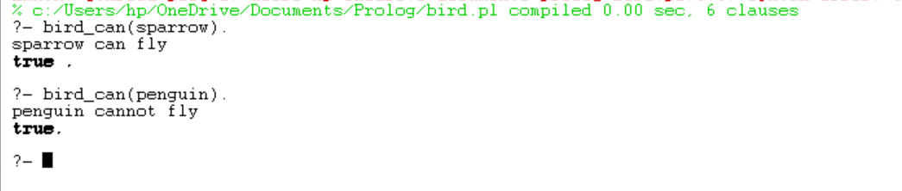

1. Write the prolog program to implement family

tree

Pam, Liz, Ann and Pat are female, while Tom,

Bob and Jim are male persons.

Using this information, define the following

relations:

•Define the “mother” relation:

•Define the “father” relation:

•Define the “grandfather” relation:

•Define the “grandmother” relation:

•Define the “sister” relation

Define the “brother” relation

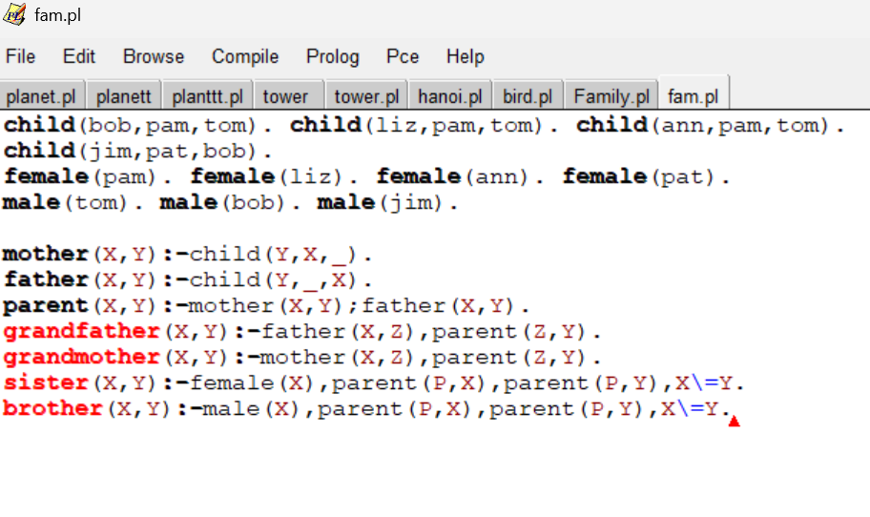

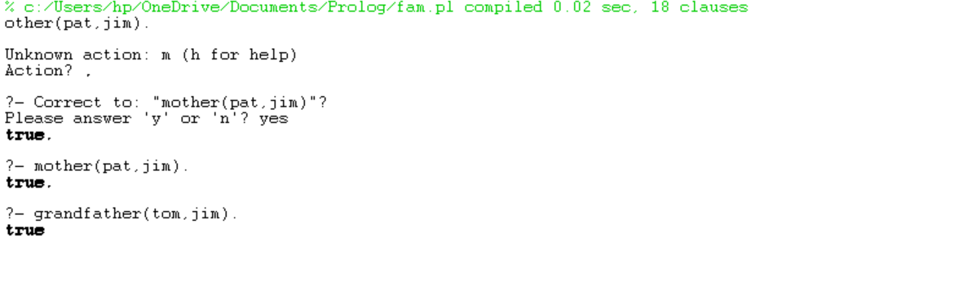

1. Write a Prolog Program to suggest Dieting System based on Disease.

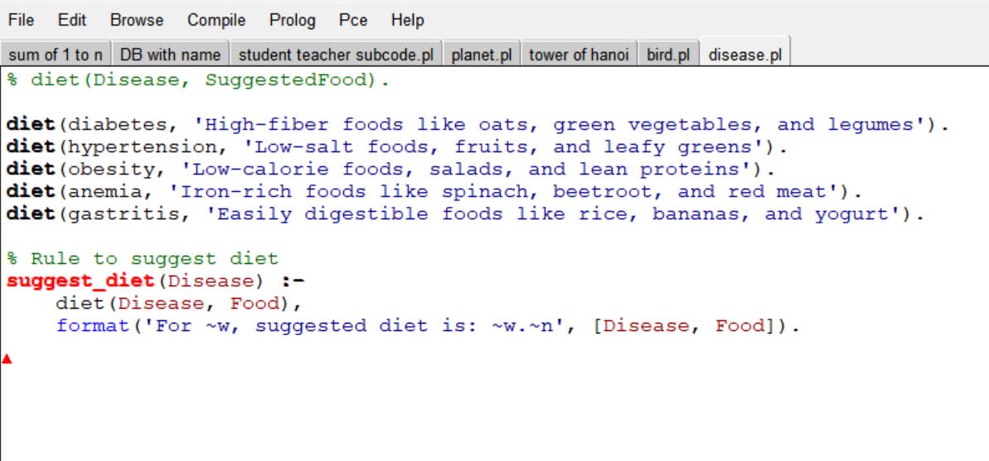

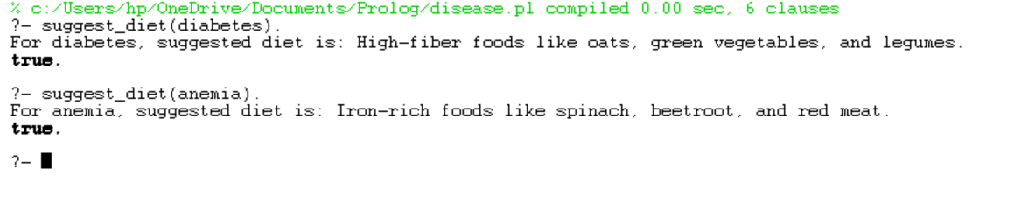

1. Monkey banana problem

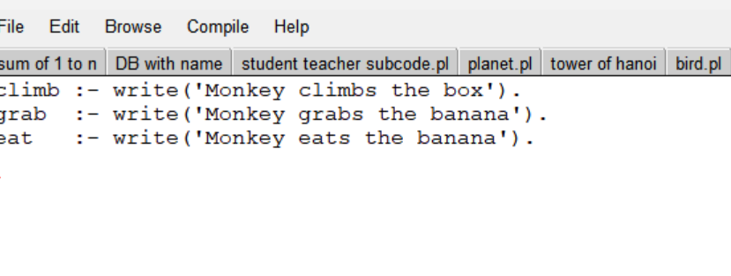

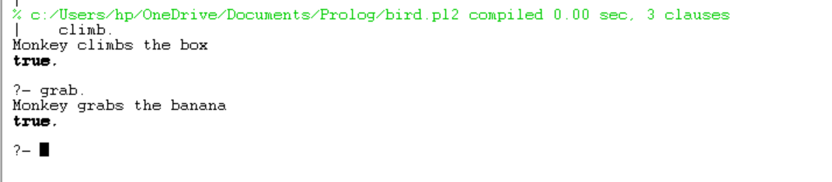

1. Prolag program fruit and its colour backtracking

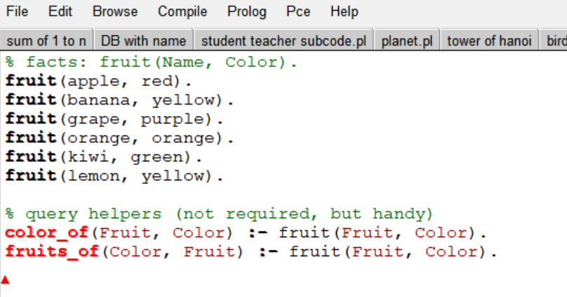

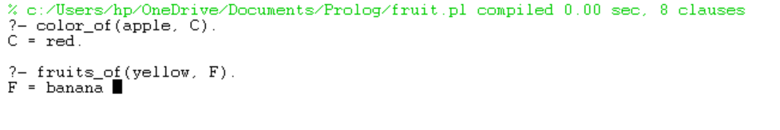

1. Implement Best search algorithm

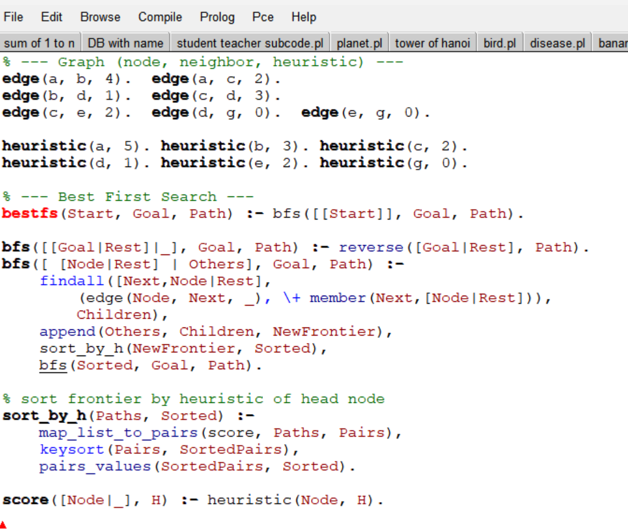

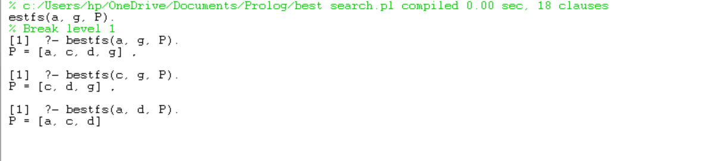

1. Prolag program for medical diagnose

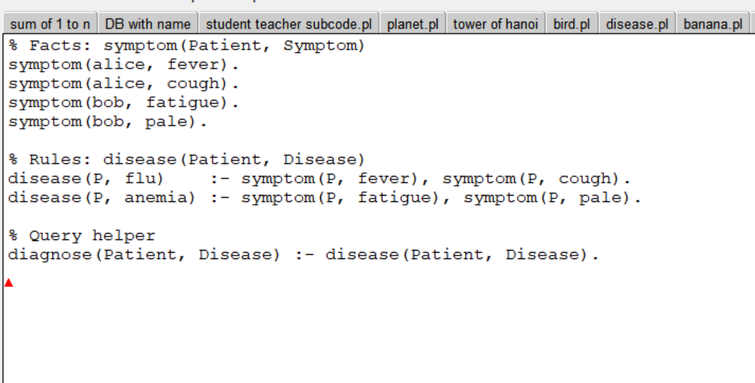

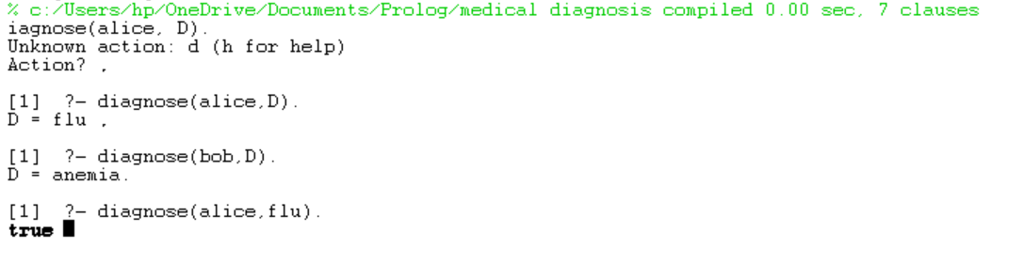

1. Prolag program for forward chaining

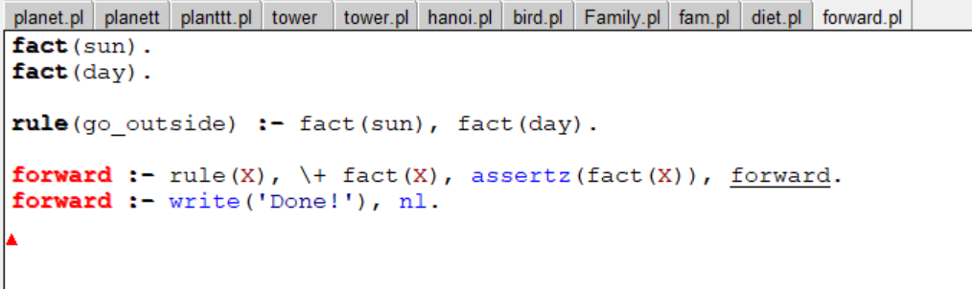

1. Prolag program for backward chaining

